***UDC*** ***378.147:78:004.9:78:378.4(476)***

***Feng Xiaoyin***

***Gomel, F. Skorina Gomel State University***

**ANALYSIS OF DIGITAL MUSIC EDUCATION IN BELARUSIAN UNIVERSITIES**

***УДК 378.147:78:004.9:78:378.4(476)***

***Фэн Сяоинь***

***Гомель, Гомельский государственный университет им. Ф. Скорины***

**АНАЛИЗ ЦИФРОВОГО МУЗЫКАЛЬНОГО ОБРАЗОВАНИЯ   
В УНИВЕРСИТЕТАХ БЕЛАРУСИ**

С быстрым развитием цифровых технологий цифровое музыкальное образование постепенно стало важным компонентом глобального музыкального образования. Существует много типов цифрового музыкального образования, включая использование онлайн-курсов, цифровых аудио рабочих станций (DAW), виртуальных инструментов, инструментов композиции искусственного интеллекта и других методов обучения музыке. В статье представлены результаты изучения актуального состояния цифрового музыкального образования в университетах Беларуси, и анализ будущего развития цифрового музыкального образования в Беларуси.

The world is undergoing a great transformation not seen in a century. With the development of the world economy, music education in Belarus is also steadily advancing. With the rapid development of digital technology, digital music education has gradually become an important component of global music education. There are many types of digital music education, including the use of online courses, digital audio workstations (DAW), virtual instruments, artificial intelligence composition tools, and other methods for music learning [1, p. 102-108].

This survey adopts a questionnaire survey method, randomly selecting Belarusian university students to fill out the questionnaire, and conducting statistical analysis on the types of music education they have received. Simultaneously search for relevant literature and news information, and draw relevant conclusions.

Thus, the situation of music education for Belarusian university students can be discussed.

This article introduces the music education received by Belarusian university students through a questionnaire survey, and analyzes the impact and thinking of future digital music education on the development of music education in Belarus.

The following figure shows the forms of music education in Belarusian universities (Figure 1):

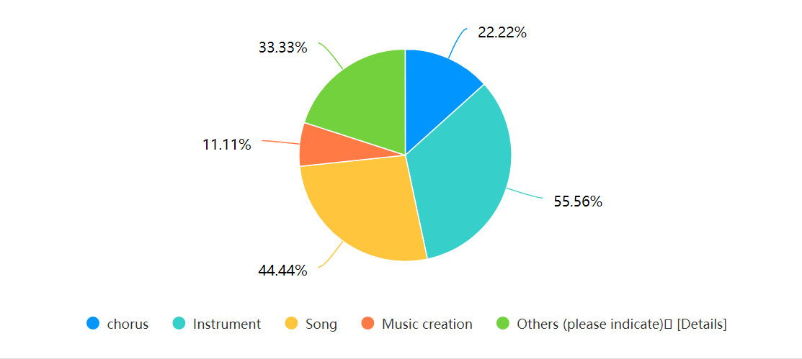

Figure 1 – The forms of music education in Belarusian universities

The data from this survey shows that the forms of music education experiences among Belarusian university students are mainly concentrated in the following categories: Chorus (22.22%), Instrument (55.56%), Song (44.44%), Music Creation (11.11%), and Others (33.33%)

From these data, it can be seen that traditional instrument playing and song singing still dominate, and are mostly offline courses with little technical assistance used. The proportion of music creation is relatively low (11.11%), mainly because composition and arrangement require professional knowledge, and the popularity of digital music tools is not enough. Among the others (33.33%), the response was «I have not received any music education».

According to the results of the first quarter of 2024, LTE (4G) mobile networks cover 99% of the population of Belarus. At the beginning of 2024, the number of mobile connections accounted for 120.5% of the total population. 89.5% of households have access to the Internet. With the progress and development of society, the digitization and informatization of education has become a trend. In recent years, the Belarusian economy has maintained steady growth, and digital technology has penetrated into all aspects of education [2]. However, according to the survey questionnaire report, some universities in Belarus still focus on traditional music teaching and have not fully integrated digital music courses. Additionally, due to limitations in equipment and resources, some students may face limitations in digital music learning due to a lack of professional music production equipment or software licenses.

The concept of «Music Computer Technology» (MCT) has been firmly established in modern teaching theory and practice. Russian scientists and musicians played a decisive role in its development, first of all the team of employees of the Pedagogical and Methodological Laboratory «Music and Computer Technology» of the Russian State Pedagogical University, headed by I. B. Gorbunova. MCT should be considered as a system of various activities aimed at copying, editing, processing, producing, recording and storing musical materials in musical notation or sound format using electronic, computer equipment and software [3, p. 168-181].

The music education of Belarusian university students still focuses on traditional instrument playing and singing, but digital music education has become an undeniable trend. In order to promote the development of digital music education, it is suggested to: promote the construction of digital music courses in universities and increase the popularity of digital music teaching; Strengthen teacher training to enable teachers to master new technologies such as DAW and AI music creation, and to teach students how to use digital tools for music learning; provide equipment support, encourage schools to establish digital music laboratories, and lower the threshold for students to learn digital music; by combining online educational resources, students can learn music anytime and anywhere, enhancing their ability for self-directed learning. Music education in Belarus is at a critical stage of digital transformation, and in the future, digital tools should be fully utilized to make music education more efficient, convenient, and diversified, so that more college students can benefit from the innovation of digital music technology.

:

**Bibliography**

1. Huang, Jingwen. Visual Analysis of Domestic Research on Digital Educational Resources / Huang Jingwen, Yang Rui // Legal System and Economics – 2022 – No. 31 (4) – P. 102-108.

2. Belarus ranks 22nd among 132 countries in terms of ICT penetration / corr. BelTA // Belarusian news / – Access mode <https://chn.belta.by/society/view/13222-26897-2024> – Access date: 05/27/2024.

3. Горбунова, И. Б. Музыкально-компьютерные технологии в системе современного музыкального образования: опыт терминологического анализа. / И. Б. Горбунова, К. Ю. Плотников // Проблемы музыкальной науки – 2020 – No. 40 (3) – C. 168–181.